Air quality monitoring system

Name : Mary Stella. A

roll no: AU210521106034

# Definition:

An air quality monitoring system is a network of sensors and equipment designed to measure and assess the quality of the air in a specific location. These systems typically monitor various air pollutants, such as particulate matter (PM2.5 and PM10), volatile organic compounds (VOCs), nitrogen oxides (NOx), sulfur dioxide (SO2), carbon monoxide (CO), ozone (O3), and more.

# Phase 2- Innovation :

Integrating a payment system via QR code and implementing a seamless navigation feature within the app would enhance the air quality experience significantly. Let’s incorporate these features into the existing steps:

# Procedure :

**Define Objectives and Location:**

Determine the purpose of your monitoring system (e.g., public health, environmental compliance, research).

Choose the location where you want to monitor air quality (urban areas, industrial sites, residential neighborhoods).

**Select Parameters:**

Decide which air pollutants you want to measure based on your objectives.

Common parameters include PM2.5, PM10, CO, NO2, SO2, O3, VOCs, and more.

**Choose Monitoring Equipment:**

Select appropriate monitoring equipment for the chosen parameters.

Ensure that the equipment is accurate, calibrated, and meets regulatory standards.

**Site Selection:**

Identify suitable locations for sensor placement, considering factors like pollution sources and accessibility.

D**ata Acquisition System:**

Set up data acquisition and transmission systems to collect data from sensors.

This can involve wired or wireless connections, data loggers, and secure data storage.

**Sensor Calibration:**

Calibrate the sensors regularly to maintain accuracy in measurements.

**Data Validation and Quality Control:**

Implement procedures to validate and control the quality of collected data.

**Data Visualization:**

Create a user-friendly interface or dashboard to display real-time air quality data.

Make this information accessible to stakeholders and the public.

Al**ert System:**

Establish threshold levels for pollutants and configure an alert system to notify relevant authorities and the public when air quality deteriorates.

**Data Analysis:**

Use historical data to identify trends, patterns, and sources of pollution.

Conduct statistical analysis and modeling if necessary.

C**ompliance and Reporting:**

Ensure compliance with local, regional, and national air quality regulations.

Prepare and submit regular reports to regulatory agencies.

M**aintenance and Calibration:**

Regularly maintain and calibrate monitoring equipment to ensure accuracy.

Replace sensors and components as needed.

**Community Engagement:**

Engage with the community to raise awareness and encourage responsible behavior to improve air quality.

Upgrades and Expansion:

Consider system upgrades and expansions as needs change and technology advances.

**Data Sharing:**

Share air quality data with researchers, policymakers, and the public to promote transparency and awareness.

**Emergency Response Plan:**

Develop an emergency response plan to address severe air quality events.

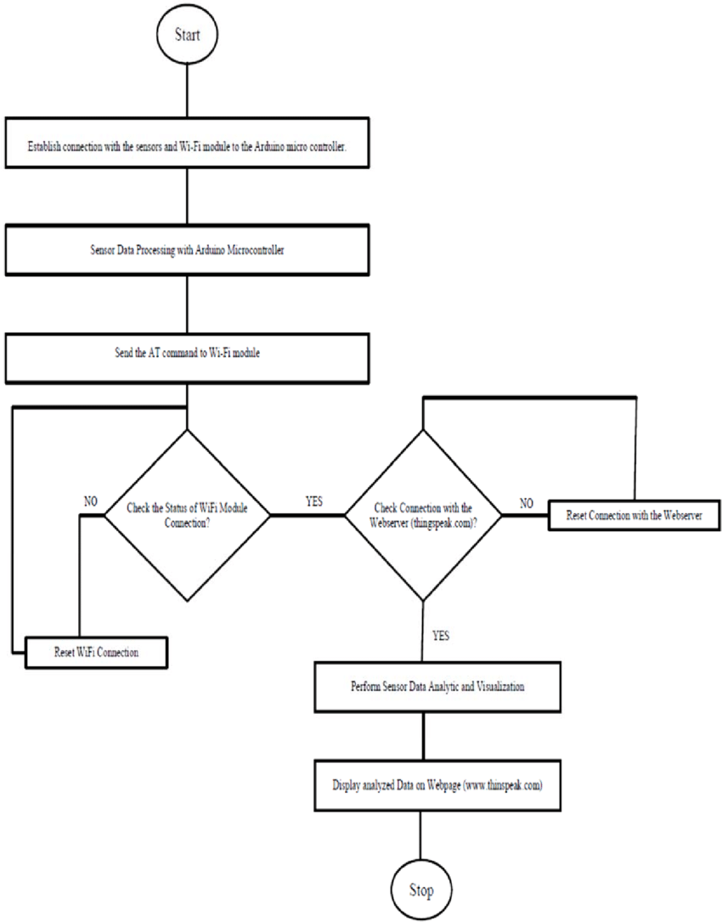

Conclusion

Remember that setting up an air quality monitoring system can be complex and often requires expertise in environmental monitoring and data analysis. It's essential to collaborate with relevant agencies and experts to ensure the system's success and reliability.